Romdb es una lista muy completa y actualizada de juegos MSX, por favor, visita la web: [openMSX ROM Database](https://romdb.vampier.net/index.php" \t "_blanck)

[Download Romdb](https://romdb.vampier.net/archive.php)

Una vez descargado el archivo necesitarás descargar el Precompiled Binaries for Windows: <https://www.sqlite.org/download.html> que es un sistema gestor de bases de datos portable y muy extendido.

Ahora descarga el archivo Extra Screenshots.zip con las imágenes del famoso launcher blueMSX y el que relacciona las imágenes con los campos sha1 que contienen los roms de la base de datos llamado extra-data.dat [Disponible en: msxlaunchers.info/download.html](http://msxlaunchers.info/download.html)

Muchas felicidades a todos por el gran trabajo!!

Comandos sqlite3:

Open database

sqlite3.exe databaseName.db 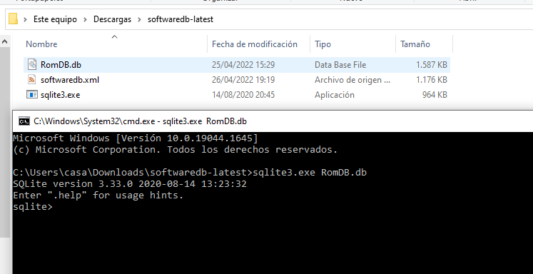

Show databases

.tables 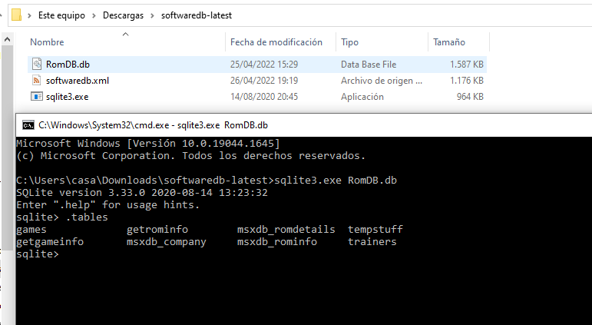

**Table games**

.schema tableName 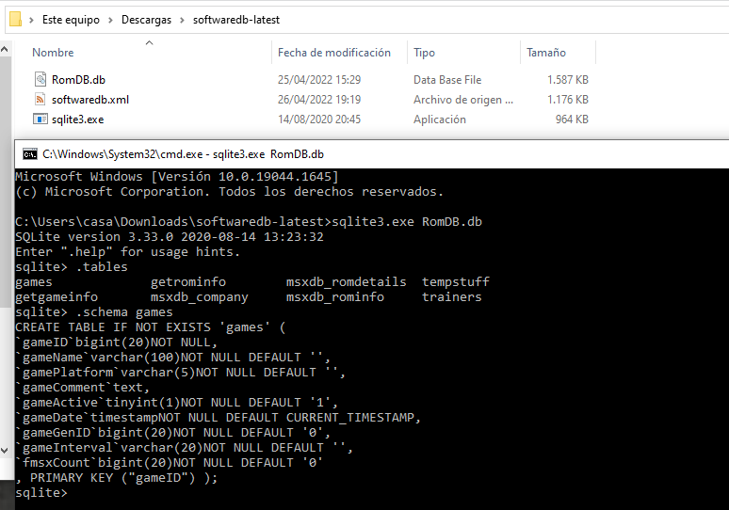

Las tablas más importantes son msxdb\_romInfo, msxdb\_romdetails

**sqlite> .schema msxdb\_rominfo**

CREATE TABLE IF NOT EXISTS 'msxdb\_rominfo' (

`GameID`int(11)NOT NULL,

`GenMSXId`int(11)DEFAULT NULL,

`GameName`varchar(255)DEFAULT NULL,

`Year`varchar(4)DEFAULT NULL,

`CompanyID1`int(11)DEFAULT NULL,

`CompanyID2`int(11)DEFAULT NULL,

`Platform`varchar(255)DEFAULT NULL

, PRIMARY KEY ("GameID") );

sqlite> select \* from msxdb\_rominfo where GameName like "frogger"

...> ;

355|70|Frogger|1983|15|0|MSX1

1373|0|Frogger|1983|771||ColecoVision

2259|0|Frogger|1983|771|0|MSX1

**Tabla msxdb\_romdetails**

CREATE TABLE IF NOT EXISTS 'msxdb\_romdetails' (

`HashID`int(11)NOT NULL,

`GameID`int(11)DEFAULT NULL,

`RomType`varchar(255)DEFAULT NULL,

`SHA1`varchar(255)NOT NULL,

`Remark`varchar(255)DEFAULT NULL,

`Meta`varchar(255)DEFAULT NULL,

`Dump`varchar(255)DEFAULT NULL,

`Active`int(11)DEFAULT NULL,

'StillForSale' BOOLEAN DEFAULT (0) ,

'Preferred' BOOLEAN,

'IP' TEXT,

'CreateDtTM' DATETIME DEFAULT CURRENT\_TIMESTAMP ,

PRIMARY KEY ("HashID")

);

**sqlite> .schema msxdb\_company**

CREATE TABLE IF NOT EXISTS 'msxdb\_company' (

`company\_id`int(11)NOT NULL,

`shortname`varchar(100)NOT NULL DEFAULT '',

`website`varchar(200)DEFAULT NULL,

`amateur`tinyint(1)NOT NULL DEFAULT '0',

`country`char(3)DEFAULT NULL,

`fullname`varchar(200)DEFAULT NULL,

`notes`text,

`hw\_notes`text,

`main\_company`int(11)DEFAULT'0',

`sub\_company`int(11)DEFAULT'0',

`address`text,

`birthyear`int(11)DEFAULT'0',

`deathyear`int(11)DEFAULT'0',

`developer\_view`int(11)DEFAULT'0',

`publisher\_view`int(11)DEFAULT'0',

`gamelist`tinyint(1)DEFAULT'0',

`has\_logo`tinyint(4)NOT NULL DEFAULT '0',

`insert\_date`dateNOT NULL DEFAULT '0000-00-00',

`updated\_on`dateNOT NULL DEFAULT '0000-00-00',

`insert\_by`int(11)NOT NULL DEFAULT '0',

`updated\_by`int(11)NOT NULL DEFAULT '0'

, PRIMARY KEY ("company\_id")

);

<https://www.msx.org/forum/msx-talk/openmsx/openmsx-romdb-download>

Tabla games

CREATE TABLE IF NOT EXISTS 'games' (

`gameID`bigint(20)NOT NULL,

`gameName`varchar(100)NOT NULL DEFAULT '',

`gamePlatform`varchar(5)NOT NULL DEFAULT '',

`gameComment`text,

`gameActive`tinyint(1)NOT NULL DEFAULT '1',

`gameDate`timestampNOT NULL DEFAULT CURRENT\_TIMESTAMP,

`gameGenID`bigint(20)NOT NULL DEFAULT '0',

`gameInterval`varchar(20)NOT NULL DEFAULT '',

`fmsxCount`bigint(20)NOT NULL DEFAULT '0'

, PRIMARY KEY ("gameID") );

Ejemplo de select

43|F1 Spirit - The Way To Formula 1|MSX||1|2017-04-13 00:14:12|905|time 1|173

Buscando a frogger

sqlite> select \* from msxdb\_romdetails where GameID>0 and GameID<10;

1|1|auto|150B249B6402ED89ED03CC7125F9472C931DCB2A|||Unknown|1||on||2020-03-06 03:29:45

2|2|auto|FD15698518172BCDE3318F08EE032531CBBB9F5D|||Unknown|1|0|||2020-03-06 03:29:45

3|2|auto|33536DAC686B375BA13FAF76A3BAF2D6978904E0|||GoodMSX|1|0|on||2020-03-06 03:29:45

4|3|ASCII8|0733CD627467A866846E15CAF1770A5594EAF4CC|||GoodMSX|1||on||2020-03-06 03:29:45

5|3|ASCII8|DA397E783D677D1A78FFF222D9D6CB48B915DADA|||Unknown|1||||2020-03-06 03:29:45

6|3|Konami|BA07B1B585386F887D4C7E457210B3FCE819709A|||Unknown|1||||2020-03-06 03:29:45

7|3|Konami|DD1E87A16E5FB38D9D729EF7EDC6DA21146A99FE|[a]||Unknown|1||||2020-03-06 03:29:45

8|3|Konami|9C544426A02312B7148249EF20AE6E2021B45DB4|||Unknown|1||||2020-03-06 03:29:45

9|4|ASCII8|C9135B1E451193BD4C06D8143EACA934CC89FE05|||GoodMSX|1||on||2020-03-06 03:29:45

10|4|ASCII8|D9826CB2044ED0224124F2F31D0BDC1FB840D81C|||Unknown|1||||2020-03-06 03:29:45

11|4|Konami|2FC15EF2C728A2472CFA3A34053E07F821DC18D4|Zemina||Unknown|1||||2020-03-06 03:29:45

12|5|basic|9A63D48C4FC05E76C9DE25E5C5F2A0C99B5D1BE4|||GoodMSX|1|0|on||2020-03-06 03:29:45

13|6|basic|F8164D3872B5D54EAEAFC6DE3BB98A472F0C828D|||GoodMSX|1|0|on||2020-03-06 03:29:45

14|6|basic|6FE8C1725C35D85A5E489C0C8D21134DEF09ECFB|[a1]||GoodMSX|1|0|||2020-03-06 03:29:45

15|7|basic|8F71DDDD429173DF7CE52C5245AF1A76B482A901|||GoodMSX|1|0|on||2020-03-06 03:29:45

16|8|auto|EAFC1AD38A8AC7E0A54917B802377AA5443AC460|v0.1b||Author|1||||2020-03-06 03:29:45

17|9|auto|5BD09E5A9669C58365C87F32A0E9A8E59680D5C9|Arabic Computers Only||Unknown|1||on||2020-03-06 03:29:45

2639|8|auto|54290E402561C6871E17076DAD41F3C8ED939688|v0.7b|RU Edition|Author|1||||2020-03-06 03:29:45

2678|8|auto|3530AB300F841EC7E92E8D38D50EBC09C5794387|v0.9b||Author|1||||2020-03-06 03:29:45

2680|8|auto|A9721F4A8C846621B77C2283E1EEE4D34433581E|v0.99b||Author|1||||2020-03-06 03:29:45

2719|8|auto|AAC7B283B1C4453384D55625C57321FDE48B0A7D|v0.996b||Author|1||on||2020-03-06 03:29:45

3202|1|auto|A7C116E987F561AAA6199C3018433C431268CA86|||Unknown|1||||2020-03-06 03:29:45

3429|3|Konami|061AC6C59E0BCF4D315CB7329BCCB955F6AF4001|Zemina Hack||Unknown|1||||2020-03-06 03:29:45

4150|9|auto|6898910ED409DAEE48C8F9F5B20505330D46F714|Arabic Computers Only||Unknown|1||||2020-03-06 03:29:45

5886|7|auto|6335A69678114D1777EF09B07881EEB379BA04F3|[a]||Unknown|1|0|||2020-03-06 03:29:45

Ejemplo select:

sqlite> select \* from msxdb\_romdetails where GameID=9;

17|9|auto|5BD09E5A9669C58365C87F32A0E9A8E59680D5C9|Arabic Computers Only||Unknown|1||on||2020-03-06 03:29:45

4150|9|auto|6898910ED409DAEE48C8F9F5B20505330D46F714|Arabic Computers Only||Unknown|1||||2020-03-06 03:29:45

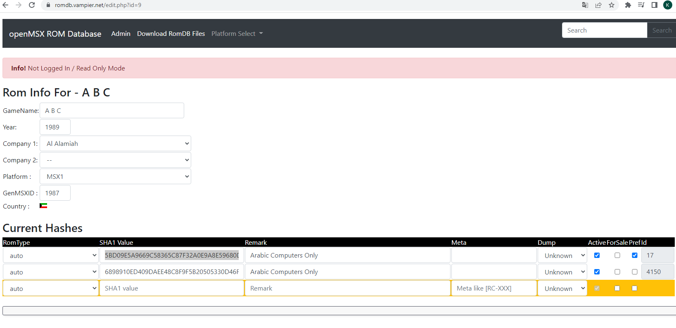

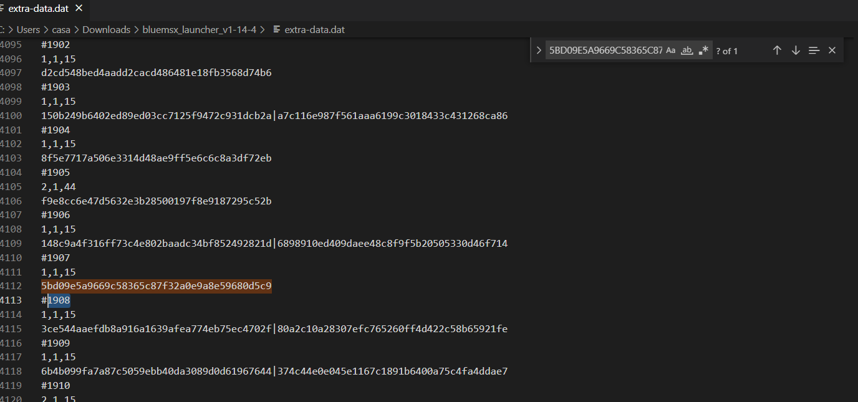

Tabla msxdb\_company

CREATE TABLE IF NOT EXISTS 'msxdb\_company' (

`company\_id`int(11)NOT NULL,

`shortname`varchar(100)NOT NULL DEFAULT '',

`website`varchar(200)DEFAULT NULL,

`amateur`tinyint(1)NOT NULL DEFAULT '0',

`country`char(3)DEFAULT NULL,

`fullname`varchar(200)DEFAULT NULL,

`notes`text,

`hw\_notes`text,

`main\_company`int(11)DEFAULT'0',

`sub\_company`int(11)DEFAULT'0',

`address`text,

`birthyear`int(11)DEFAULT'0',

`deathyear`int(11)DEFAULT'0',

`developer\_view`int(11)DEFAULT'0',

`publisher\_view`int(11)DEFAULT'0',

`gamelist`tinyint(1)DEFAULT'0',

`has\_logo`tinyint(4)NOT NULL DEFAULT '0',

`insert\_date`dateNOT NULL DEFAULT '0000-00-00',

`updated\_on`dateNOT NULL DEFAULT '0000-00-00',

`insert\_by`int(11)NOT NULL DEFAULT '0',

`updated\_by`int(11)NOT NULL DEFAULT '0'

, PRIMARY KEY ("company\_id") );